**FULL STACK PROJECT**

**(2020-21)**

**Fitness-Treat**

## PROJECT REPORT

## 

## Institute of Engineering & Technology

## *Submitted by-*

## Mukul Agrawal(C/181500397)

## Krishna Gupta(C/181500330)

## Mukund Agrawal(C/181500401)

***Supervised By: -***

**Mr. Pankaj Kapoor**

**Assistant Professor**

**GLA University, Mathura**

**Department of Computer Engineering & Applications Department**



**Department of computer Engineering and Applications**

**GLA University, Mathura**

**17 km. Stone NH#2, Mathura-Delhi Road, P.O. – Chaumuha,**

**Mathura – 281406**

**Declaration**

We hereby declare that the work which is being presented in the Full Stack Project **“**Fitness-Treat**”**, in partial fulfillment of the requirements for Full Stack Projectand submitted to the Department of Computer Engineering and Applications of GLA University, Mathura, is an authentic record of our own work carried under the supervision of **Mr. Pankaj Kapoor Assistant Professor** **of computer Engineering Department.**

Signature: __________________

Name of Candidates: Mukul Agrawal

University Roll No. : 181500397

Signature: __________________

Name of Candidates: Krishna Gupta

University Roll No. : 181500330

Signature: __________________

Name of Candidates: Mukund Agrawal

University Roll No. : 181500401

**ACKNOWLEDGEMENT**

We have taken efforts in this project. However, it would not have been possible without the kind support and help of many individuals. On the completion of this project we would like to extend our sincere thanks to all of them. We are highly indebted to this project guide **Mr. Pankaj Kapoor Assistant Professor of Department of Computer Engineering and Applications of GLA University** for their guidance and constant supervision as well as for providing necessary information regarding the project. We wish to extend our sincere gratitude to **Prof. Anand Singh Jalal, Head of Department of Computer Engineering and Applications and faculty of CEA Department of GLA University** for their guidance, encouragement and give this opportunity and valuable suggestion which prove extremely useful and helpful in the completion of this report. We would also like to thank all those who directly or indirectly supported or helped us in completing our project in time. We would like to express our gratitude towards our parents and member of our college for their kind cooperation and encouragement which helped me in completion of this project. All of them have willingly helped us out with their abilities.

Thanks.

**ABSTRACT**

To put it simply, physical activity and exercise is important for everyone. Children, adolescents, and adults of all ages need regular physical activity. Physical activity promotes good health, and you should stay active throughout all stages of your life regardless of your body type or BMI.

Understanding the benefits of physical fitness and knowing how active you should be can help you maintain good health and improve your overall quality of life.

**Contents**

|  |  |
| --- | --- |
| **Topic**  Declaration  Acknowledgement  Abstract | **Pg.no.**  2  3  4 |
| **Chapter1** **Introduction**   * 1. Present Problem Statement   2. Proposed System | **7**  7  7 |
| * 1. Overview   2. Motivation | 7  8 |
| 1.5 Objectives | 8 |
| **Chapter2** **Software Requirement Analysis** | **9** |
| 2.1 Requirement Analysis | 9 |
| 2.1.1 Hardware Requirement | 9 |
| 2.1.2 Software Requirement | 10 |
| 2.1.3 Tools and Technologies | 10 |
| 2.2 Feasibility Study | 13 |
| 2.2.1 Technical Feasibility | 13 |
| 2.2.2 Operational Feasibility | 14 |
| 2.2.3 Economical Feasibility | 15 |
| 2.3 Analysis | 15 |
| 2.4 Summary of Modules | 16 |
| **Chapter3 Software Design** | **18** |
| 3.1 UML Diagram | 18 |
| 3.2 Use case diagram | 19 |
| **Chapter 4 Implementation & User Interface**  **Chapter 5 Software Testing** | **21**  **27** |

|  |  |
| --- | --- |
| 5.1 Testing | 27 |
| 5.2 Objectives of Software Testing | 27 |
| 5.3 Software Testing | 28 |
| 5.3.1 White Box Testing | 28 |
| 5.3.2 Black Box Testing | 28 |
| 5.4 Testing Fundamentals | 29 |
| 5.5 Testing Information flow | 29 |
| **Chapter 6 Conclusion** | **30** |
| **Chapter 7 References** | **31** |

1. **INTRODUCTION**
   1. **Present Problem Statement**

"**Fitness**" is a broad term that means something different to each person, but it refers to your own optimal health and overall well-being. Being fit not only means physical health, but emotional and mental health, too. It defines every aspect of your health. Smart eating and active living are fundamental to fitness.

According to the United States Department of Health and Human Services, physical fitness is defined as “a set of attributes that people have or achieve that relates to the ability to perform physical activity.”

* 1. **Proposed System**

Proposed system will give you the proper guidance for fitness because Physical activity or exercise can improve your health and reduce the risk of developing several diseases like type 2 diabetes, cancer and cardiovascular disease. Physical activity and exercise can have immediate and long-term health benefits. Most importantly, regular activity can improve your quality of life. A minimum of 30 minutes a day can allow you to enjoy these benefits. It will provide fitness tips, exercises and diet healthy food. Customer will be able to do these exercises. There are many sections, customer will be able to see the many sections.

This system provides a lot of features for customers. The customers can see the trainers and machines. Customers can later contact us to join the fitness-Treat. These website is good for gym trainers as they want to start their Gym.

* 1. **Overview**

We know that staying active is one of the best ways to keep our bodies healthy. But did you know it can also improve your overall well-being and quality of life?

Regular physical activity can relieve stress, anxiety, depression and anger. You know that "feel good sensation" you get after doing something physical? Think of it as a happy pill with no side effects! Most people notice they feel better over time as physical activity becomes a regular part of their lives. Without regular activity, your body slowly loses its strength, stamina and ability to function properly. It’s like the old saying: you don’t stop moving from growing old, you grow old from stopping moving. Exercise increases muscle strength, which in turn increases your ability to do other physical activities.

* 1. **Motivation**
* Helps you quit smoking and stay tobacco-free.
* Boosts your energy level so you can get more done. Helps you spend more time outdoors.
* Helps you manage stress and tension. Helps you fall asleep faster and sleep more soundly.
* Promotes a positive attitude and outlook Improves your self-image and self-confidence.

## Objective

The ultimate objective of fitness is longevity with no disease, no any physical pain, and happiness. It is hard to get this objective of life but not impossible. The happiness of life can be obtained through physical fitness. There are many ways people try get physical fitness, some of them are better lifestyle, better diet, gym, yoga, aerobics etc. Here are some main objectives of our fitness-Treat project.

* Maintaining physical fitness can help prevent some diseases.
* With exercise, body composition can change without changing weight.
* Athletes’ hearts show different changes dependent on their chosen sport.
* Stretching to increase flexibility can ease a number of medical complaints.
* Zero levels of stress and tension
* Physical strength, stamina and flexibility
* Greater powers of concentration and self-control
* Better organ functioning
* Sense of balance and internal harmony
* Healthy & glowing skin
* Strong Immune System etc.

1. **SOFTWARE REQUIREMENT ANALYSIS**

System Analysis is a detailed study of the various operations performed by a system and their relationship within and outside the system. It is a systematic technique that defines goals and objectives the goal of the development is to deliver the system in the line with the user’s requirements, and analysis is this process.

* System study has been conducted with the following objectives in mind: -
* Identify the client’s need.
* Evaluate the system concept for feasibility.
* Perform economical and technical analysis.
* Allocate functional to hardware, software, people, database and other system elements Establish cost and schedule constraints.
* Both hardware and software expertise is required to successfully attain the objectives.

## 2.1 Requirement Analysis

Information gathering is usually the first phase of the software development project. The purpose of this phase is to identify and document the exact requirements for the system. The user’s request identifies the need for a new information system and on investigation re-defined the new problem to be based on MIS, which supports management. The objective is to determine whether the request is valid and feasible before a recommendation is made to build a new or existing manual system. The major steps are –

* + - Defining the user requirements.
    - Studying the present system to verify the problem.
    - Defining the performance expected by the candidate to use requirement.

**2.1.1 Hardware Requirements**

Processor : Intel Dual Core Processor

Speed : 1.5 GHZ

RAM : 2 GB

Hard Disk : 20 GB of free space

#### **2.1.2 Software Requirements**

Operating System : Window XP and higher

Front End : HTML, CSS, Java Script, Bootstrap

**2.1.3 Tools and Technology Tools**

## VISUAL STUDIO CODE:

Microsoft Visual Studio is an integrated development environment (IDE) from Microsoft. It is used to develop computer programs, as well as websites, web apps, web services and mobile apps. Visual Studio uses Microsoft software development platforms such as Windows API, Windows Forms, Windows Presentation Foundation, Windows Store and Microsoft Silverlight. It can produce both native code and managed code.

Visual Studio includes a code editor supporting IntelliSense (the code completion component) as well as code refactoring. The integrated debugger works both as a source-level debugger and a machine-level debugger. Other built-in tools include a code profiler, forms designer for building GUI applications, web designer, class designer, and database schema designer. It accepts plug-ins that enhance the functionality at almost every level—including adding support for source control systems (like Subversion and Git) and adding new toolsets like editors and visual designers for domain-specific languages or toolsets for other aspects of the software development lifecycle (like the Team Foundation Server client: Team Explorer).

Visual Studio supports 36 different programming languages and allows the code editor and debugger to support (to varying degrees) nearly any programming language, provided a language-specific service exists. Built-in languages include C, C++, C++/CLI, and Visual Basic

.NET, C#, F#, JavaScript, Typescripts, XML, XSLT, HTML, and CSS. Support for other languages such as Python, Ruby, Node.js, and M among others is available via plug-ins. Java (and J#) were supported in the past.

Microsoft Visual Studio is an [integrated development environment](https://en.wikipedia.org/wiki/Integrated_development_environment) (IDE) from [Microsoft](https://en.wikipedia.org/wiki/Microsoft). It is used to develop [computer programs,](https://en.wikipedia.org/wiki/Computer_program) as well as [websites](https://en.wikipedia.org/wiki/Web_site), [web apps,](https://en.wikipedia.org/wiki/Web_app) [web](https://en.wikipedia.org/wiki/Web_service) [services](https://en.wikipedia.org/wiki/Web_service) and [mobile apps](https://en.wikipedia.org/wiki/Mobile_app). Visual Studio uses Microsoft software development platforms such as [Windows API,](https://en.wikipedia.org/wiki/Windows_API) [Windows Forms,](https://en.wikipedia.org/wiki/Windows_Forms) [Windows Presentation Foundation,](https://en.wikipedia.org/wiki/Windows_Presentation_Foundation) [Windows](https://en.wikipedia.org/wiki/Windows_Store) [Store](https://en.wikipedia.org/wiki/Windows_Store) and [Microsoft Silverlight.](https://en.wikipedia.org/wiki/Microsoft_Silverlight) It can produce both [native code](https://en.wikipedia.org/wiki/Machine_code) and [managed code.](https://en.wikipedia.org/wiki/Managed_code)

Visual Studio includes [a code editor](https://en.wikipedia.org/wiki/Code_editor) supporting [IntelliSense](https://en.wikipedia.org/wiki/IntelliSense) (the [code completion](https://en.wikipedia.org/wiki/Code_completion) component) as well as [code refactoring.](https://en.wikipedia.org/wiki/Code_refactoring) [The integrated debugger](https://en.wikipedia.org/wiki/Microsoft_Visual_Studio_Debugger) works both as a source-level debugger and a machine-level debugger. Other built-in tools include a [code profiler,](https://en.wikipedia.org/wiki/Profiling_(computer_programming)) forms designer for building [GUI](https://en.wikipedia.org/wiki/GUI) applications, [web designer,](https://en.wikipedia.org/wiki/Web_designer) [class](https://en.wikipedia.org/wiki/Class_(computing)) designer, and [database schema](https://en.wikipedia.org/wiki/Database_schema) designer. It accepts plug-ins that enhance the functionality at almost every level—including adding support for [source control](https://en.wikipedia.org/wiki/Source_control) systems (like [Subversion](https://en.wikipedia.org/wiki/Subversion_(software)) and [Git](https://en.wikipedia.org/wiki/Git)) and adding new toolsets like editors and visual designers f[or domain-specific languages](https://en.wikipedia.org/wiki/Domain-specific_language) or toolsets for other aspects of the [software development lifecycle](https://en.wikipedia.org/wiki/Software_development_lifecycle) (like the [Team Foundation Server](https://en.wikipedia.org/wiki/Team_Foundation_Server) client: Team Explorer).

## WEB BROWSER:

A **web browser** (commonly referred to as a **browser**) is a [software application](https://en.wikipedia.org/wiki/Software_application) for accessing information on the [World Wide Web](https://en.wikipedia.org/wiki/World_Wide_Web). Each individual [web page](https://en.wikipedia.org/wiki/Web_page), image, and video is identified by a distinct [Uniform Resource Locator](https://en.wikipedia.org/wiki/URL) (URL), enabling browsers to retrieve these resources from a [web server](https://en.wikipedia.org/wiki/Web_server) and display them on the [user'](https://en.wikipedia.org/wiki/User_(computing))s device.

A web browser is not the same thing as a [search engine](https://en.wikipedia.org/wiki/Web_search_engine), though the two are often confused. For a user, a search engine is just a [website](https://en.wikipedia.org/wiki/Website), such as [google.com](https://en.wikipedia.org/wiki/Google_Search), that stores searchable data about other websites. But to connect to a website's server and display its web pages, a user needs to have a web browser installed on their device.

The most popular browsers are [Chrome](https://en.wikipedia.org/wiki/Google_Chrome), [Firefox](https://en.wikipedia.org/wiki/Firefox), [Safari](https://en.wikipedia.org/wiki/Safari_(web_browser)), [Internet Explorer](https://en.wikipedia.org/wiki/Internet_Explorer), and [Edge](https://en.wikipedia.org/wiki/Microsoft_Edge)

* **Hypertext Markup Language (HTML):** is the standard markup language for creating web pages and web application. With Cascading Style Sheets (CSS) and JavaScript, it forms a triad of cornerstone technologies for the World Wide Web.

Web Browser receive HTML documents from a web server or from local storage and render the documents into multimedia web pages. HTML describes the structure of a web page semantically and originally included cues for the appearance of the document. HTML Elements are the building blocks of HTML pages. With HTML constructs, images and other objects such as interactive forms may be embedded into the rendered page. HTML provides a means to create structured documents by denoting structural semantics for text such as headings, paragraphs, lists, links, quotes and other items. HTML elements are delineated by tags, written using angle brackets. Tags such as <img/> and <input/>directly introduce content into the page. Other tags such as <p> surround and provide information about document text and may include other tags as sub-elements. Browsers do not display the HTML tags, but use them to interpret the content of the page. HTML can embed programs written in a scripting language such as JavaScript, which affects the behavior and content of web pages. Inclusion of CSS defines the look and layout of content. The World Wide Web Consortium (W3C), maintainer of both the HTML and the CSS standards, has encouraged the use of CSS over explicit presentational HTML since 1997. HTML code ensures the proper formatting of text and images so that your Internet browser may display them as they are intended to look. Without HTML, a browser would not know how to display text as elements or load images or other elements. HTML also provides a basic structure of the page, upon which Cascading Style Sheets are overlaid to change its appearance. One could think of HTML as the bones (structure) of a web page, and CSS as its skin (appearance).

* **CSS (Cascading Style Sheets):**

Fondly referred to as CSS, is a simple design language intended to simplify the process of making web pages presentable.CSS handles the look and feel part of a web page. Using CSS, you can control the color of the text, the style of fonts, the spacing between paragraphs, how columns are sized and laid out, what background images or colors are used, layout designs, and variations in display for different devices and screen sizes as well as a variety of other effects.

CSS is easy to learn and understand but it provides powerful control over the presentation of an HTML document. Most commonly, CSS is combined with the markup languages HTML or XHTML

* **JAVA SCRIPT(JS):**

**JavaScript** is a [high-level,](https://en.wikipedia.org/wiki/High-level_programming_language) [interpreted](https://en.wikipedia.org/wiki/Interpreted_language) [programming language](https://en.wikipedia.org/wiki/Programming_language) that conforms to the [ECMAScript](https://en.wikipedia.org/wiki/ECMAScript) specification. It is a programming language that is characterized as [dynamic,](https://en.wikipedia.org/wiki/Dynamic_programming_language) [weakly typed](https://en.wikipedia.org/wiki/Weak_typing), [prototype-based](https://en.wikipedia.org/wiki/Prototype-based_programming) and [multi-paradigm](https://en.wikipedia.org/wiki/Multi-paradigm_programming_language).

Alongside [HTML](https://en.wikipedia.org/wiki/HTML) and [CSS](https://en.wikipedia.org/wiki/CSS), JavaScript is one of the core technologies of the [World WideWeb](https://en.wikipedia.org/wiki/World_Wide_Web). JavaScript enables interactive [web pages](https://en.wikipedia.org/wiki/Web_page) and is an essential part of [web applications](https://en.wikipedia.org/wiki/Web_application). The vast majority of [websites](https://en.wikipedia.org/wiki/Website) use it, and major [web browsers](https://en.wikipedia.org/wiki/Web_browser) have a dedicated [JavaScriptengine](https://en.wikipedia.org/wiki/JavaScript_engine) to execute it.

As a multi-paradigm language, JavaScript supports [event-driven](https://en.wikipedia.org/wiki/Event-driven_programming), [functional](https://en.wikipedia.org/wiki/Functional_programming), a[nd imperative](https://en.wikipedia.org/wiki/Imperative_programming) (including [object-oriented](https://en.wikipedia.org/wiki/Object-oriented_programming) and [prototype-based](https://en.wikipedia.org/wiki/Prototype-based_programming)) [programming styles](https://en.wikipedia.org/wiki/Programming_paradigm). It has [APIs](https://en.wikipedia.org/wiki/Application_programming_interface) for working with text, [arrays,](https://en.wikipedia.org/wiki/Array_data_type) dates, [regular expressions](https://en.wikipedia.org/wiki/Regular_expression), and the [DOM](https://en.wikipedia.org/wiki/Document_Object_Model), but the language itself does not include any [I/O,](https://en.wikipedia.org/wiki/Input/output) such as [networking](https://en.wikipedia.org/wiki/Computer_network), [storage,](https://en.wikipedia.org/wiki/Data_storage) or [graphics](https://en.wikipedia.org/wiki/Computer_graphics) facilities. It relies upon the host environment in which it is embedded to provide these features. Initially only implemented [client-side](https://en.wikipedia.org/wiki/Client-side) in web browsers, JavaScript engines are now embedded in many other types of host software, including [server-side](https://en.wikipedia.org/wiki/Server-side) in web servers and databases, and in non-web programs such as word processors and [PDF](https://en.wikipedia.org/wiki/Portable_Document_Format) software, and in runtime environments that make JavaScript available for writing mobile and desktop applications, including desktop widgets.

The terms *Vanilla JavaScript* and *Vanilla JS* refer to JavaScript not extended by any frameworks or additional libraries. Scripts written in Vanilla JS are plain JavaScript code.

Although there are similarities between JavaScript and [Java](https://en.wikipedia.org/wiki/Java_(programming_language)), including language name, [syntax](https://en.wikipedia.org/wiki/Syntax_(programming_languages)), and respective [standard libraries,](https://en.wikipedia.org/wiki/Standard_library) the two languages are distinct and differ greatly in design. JavaScript was influenced by programming languages such as [self](https://en.wikipedia.org/wiki/Self_(programming_language)) and scheme[.](https://en.wikipedia.org/wiki/Scheme_(programming_language))

* **Bootstrap:**

Bootstrap is a free and open front-end framework for designing websites and web applications. It contains HTML - and CSS -based design templates for typography, forms, buttons, and navigation and other interface components, as well as optional JavaScript extensions. Unlike many earlier web frameworks, it concerns itself with front end development only.

Bootstrap is the second most-starred project on GitHub, with more than 129,000 stars. Bootstrap comes with several JavaScript components in the form of jQuery plugins. They provide additional user interface elements such as dialog boxes, tooltips, and carousels. They also extend the functionality of some existing interface elements, including for example an auto-complete function for input fields. In version 1.3, the following JavaScript plugins are supported: Modal, Dropdown, Scrollspy, Tab, Tooltip, Popover, Alert, Button, Collapse, Carousel and Typeahead.

## 2.2 Feasibility Study

Feasibility study is the process of determination of whether or not a project is worth doing. Feasibility studies are undertaken within tight time constraints and normally culminate in a written and oral feasibility report. I have taken a fixed time in feasibility study with my co-developer*.*

#### **2.2.1 Technical feasibility:**

This is concerned with specifying equipment of software and hardware that will successfully satisfy the user requirements. The technical needs of the system may vary considerably, but might include:

* The facility to produce output in a given time.
* Response time under certain condition.
* Ability to produce a certain volume of transaction at a particular speed.
* In examining technical feasibility, configuration of the system is given more importance than the actual make of hardware. The configuration should give the complete picture about the system requirements. What speeds of input and output should be achieved at particular quality of printing.

According to the definition of technical feasibility the compatibility of front- end is very important. In our project the compatibility is very good. The speed of output is very good when we enter the data and click button then the response time is very fast and give result very quick. In ever find difficulty when we use complex query or heavy transaction. The speed of transaction is always smooth and constant. This software provides facility to communicate data to distantlocation.

We use Active Server Pages and JavaScript. The designing of front-end of any project is very important so we selected Active Server Pages, HTML & CSS as front-end due to following reason:

* Easy implementation of code.
* Well define interface and database.
* Well define hand shaking of SQL Server.

With the help of above support were move defect of existing software. In future we can easily switch over any platform. To ensure that system does not halt in case of undesired situation or events. Problem effected of any module does not affect any module of the system. A change of hardware does not produce problem.

**2.2.2 Operational Feasibility:**

It is mainly related to human organizational and political aspects. The points to be considered are:

* + - * What changes will be brought with the system?
      * What organization structures are distributed structures are distributed.
      * What new skills will be required? Do the existing staff members have these skills? If not, can they be trained in due course of time?
      * At present stage all the work is done manually. So, throughput and response time is too much. Major problem is lack of security check that should have been applied.
      * Finding out the detail regarding user’s request was very difficult, because data store was in different registers and different places. In case of any problem, no one can solve the problem until the person responsible is not present.
      * Current communication is entirely on telephonic conversation or personal meetings. Post computerization staff can interact using internet.
      * Now, we will explain the last point of operational feasibility i.e. handling and keeping of software, at every point of designing I will take care that menu options are not too complex and can be easily learned and required least amount of technical skills as operators are going to be from non-computers background.

#### **2.2.3 Economic feasibility:**

Economic analysis is the most frequently used technique for evaluating the effectiveness of a proposed system. More commonly known as cost/benefit analysis: the procedure is to determine the benefits and saving that are expected from a proposed system and compare them with cost. If benefits outweighs cost, a decision is taken to design and implement the system. Otherwise, further justification or alternative in the proposed system will have to be made if it is to have a chance of being approved. This is an ongoing effort that improves in accuracy at each phase of the system life cycle.

At present Company has ten systems with following configuration:

* + - Ram 4 GB or above for fast execution and reliability
    - MOTHER Board x64 based PC
    - Color Monitor 14” and17”
    - Hard Disk 100GB
    - Hence the economic feasibility is very good.

## Analysis

System analysis is the first step towards the software building process. The purpose of system analysis is to understand the system requirements, identify the data, functional and behavioral requirements and building the models of the system for better understanding of the system.

In the process of system analysis one should first understand that, what the present system, how it works (i.e. processes) .After analyzing the points to identify the problems in the present system. Upon evaluating current problems and desired information (input and output to the system), the analyst looks towards one or more solutions. To begin with, the data objects, processing functions, and behavior of the system are defined in detail. After this models, from three different aspects of the system-data, function and behavior. The models created during the system analysis process helps in better understanding of data and control flow, functional processing, operational behavioral and information content.

## Summary of Modules

1. Home
2. About Us
3. Features
4. Gymnasts
5. Exercises
6. Diet
7. Testimonial
8. Contact

**HOME**

This is the home page of our website .This home page consist various sections.

**ABOUT US**

This section tells about the aim of our website.

**Features**

This section tells about the importance of the fitness.

**GYMNASTS**

This section contain our gym trainers. This section tells about our trainers and their name and description.

**EXERCISES**

This page contains the various exercises which we can do in our daily life.

**DIET**

This page contains all the healthy foods which can be useful for diet person.

**TESTIMONIAL**

This section contains all the formal written description or statement about the abilities, character and qualities of a person.

**CONTACT**

In this section a user can send us suggestion and contact us.

**3. SOFTWARE DESIGN**

A software design document (SDD) is a written description of a [software](http://en.wikipedia.org/wiki/Software) product, that a software designer writes in order to give a [software development](http://en.wikipedia.org/wiki/Software_development) team overall guidance to the architecture of the software project. An SDD usually accompanies an architecture diagram with pointers to detailed feature specifications of smaller pieces of the design. Practically, a design document is required to coordinate a large team under a single vision. A design document needs to be a stable reference, outlining all parts of the software and how they will work. The document is commanded to give a fairly complete description, while maintaining a high-level view of the software.

There are two kinds of design documents called HLDD (high-level design document) and LLDD (low-level design document).

The SDD contains the following documents:

* 1. The [**data design**](http://en.wikipedia.org/wiki/Data-driven_design) describes structures that reside within the software. Attributes and relationships between [data objects](http://en.wikipedia.org/wiki/Data_object) dictate the choice of [data structures](http://en.wikipedia.org/wiki/Data_structures).
  2. The [**architecture design**](http://en.wikipedia.org/wiki/Software_architecture) uses information flowing characteristics, and maps them into the program structure. The transformation mapping method is applied to exhibit distinct boundaries between incoming and outgoing data. The data flow diagrams allocate control input, processing and output along three separate modules.
  3. The [**interface design**](http://en.wikipedia.org/wiki/Interface_design) describes internal and external program interfaces, as well as the design of human interface. Internal and external interface designs are based on the information obtained from the analysis model.
  4. The [**procedural design**](http://en.wikipedia.org/wiki/Procedural_design) describes structured programming concepts using graphical, tabular and textual notations. These design mediums enable the designer to represent procedural detail that facilitates translation to code. This blueprint for implementation forms the basis for all subsequent software engineering worked.

**3.1 UML Diagrams:**

**Actor:**

A coherent set of roles that users of use cases play when interacting with the use `cases.

**Use case:**

A description of sequence of actions, including variants, that a system performs that yields an observable result of value of an actor.

UML stands for Unified Modelling Language. UML is a language for specifying, visualizing and documenting the system. This is the step while developing any product after analysis. The goal from this is to produce a model of the entities involved in the project which later need to be built. The representation of the entities that are to be used in the product being developed need to be designed.

There are various kinds of methods in software design. They are as follows:

➢ Use case Diagram

➢ Sequence Diagram

➢ Collaboration Diagram

➢ Activity Diagram

➢ State chat Diagram

**3.2 USE CASE DIAGRAMS:**

Use case diagrams model behavior within a system and helps the developers understand of what the user require. The stick man represents what’s called an actor. Use case diagram can be useful for getting an overall view of the system and clarifying who can do and more importantly what they can’t do.

Use case diagram consists of use cases and actors and shows the interaction between the use case and actors.

* The purpose is to show the interactions between the use case and actor.
* To represent the system requirements from user’s perspective.
* An actor could be the end-user of the system or an external system.

A Use case is a description of set of sequence of actions. Graphically it is rendered as an ellipse with solid line including only its name. Use case diagram is a behavioral diagram that shows a set of use cases and actors and their relationship. It is an association between the use cases and actors. An actor represents a real-world object. Primary Actor – Sender, Secondary Actor Receiver.

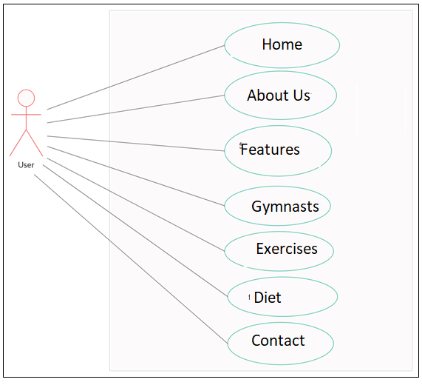

Fig1: Use case diagram

**4. Implementation and user Interface**

**Fig.4.1: Home**

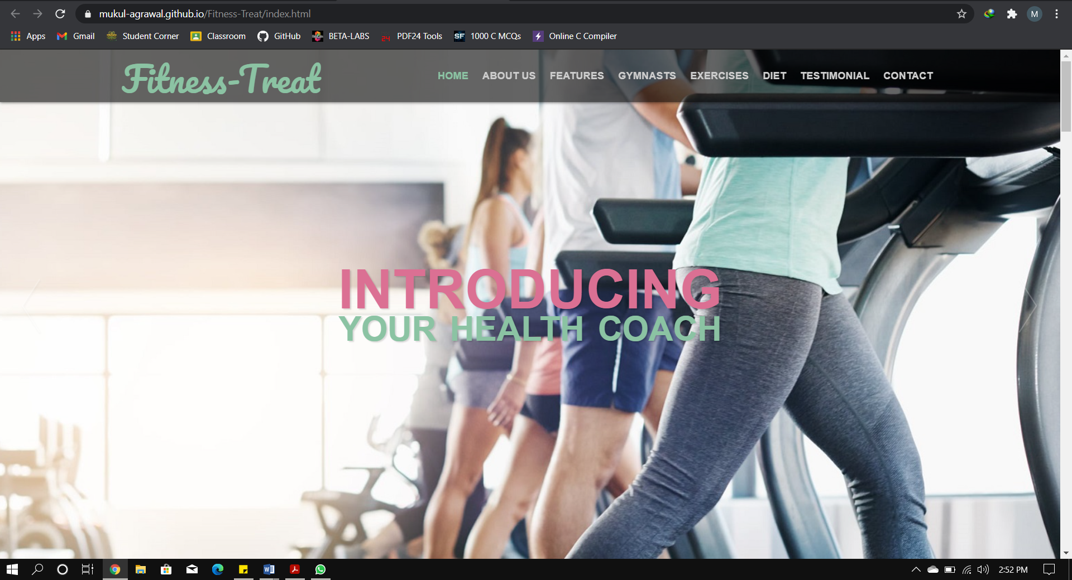

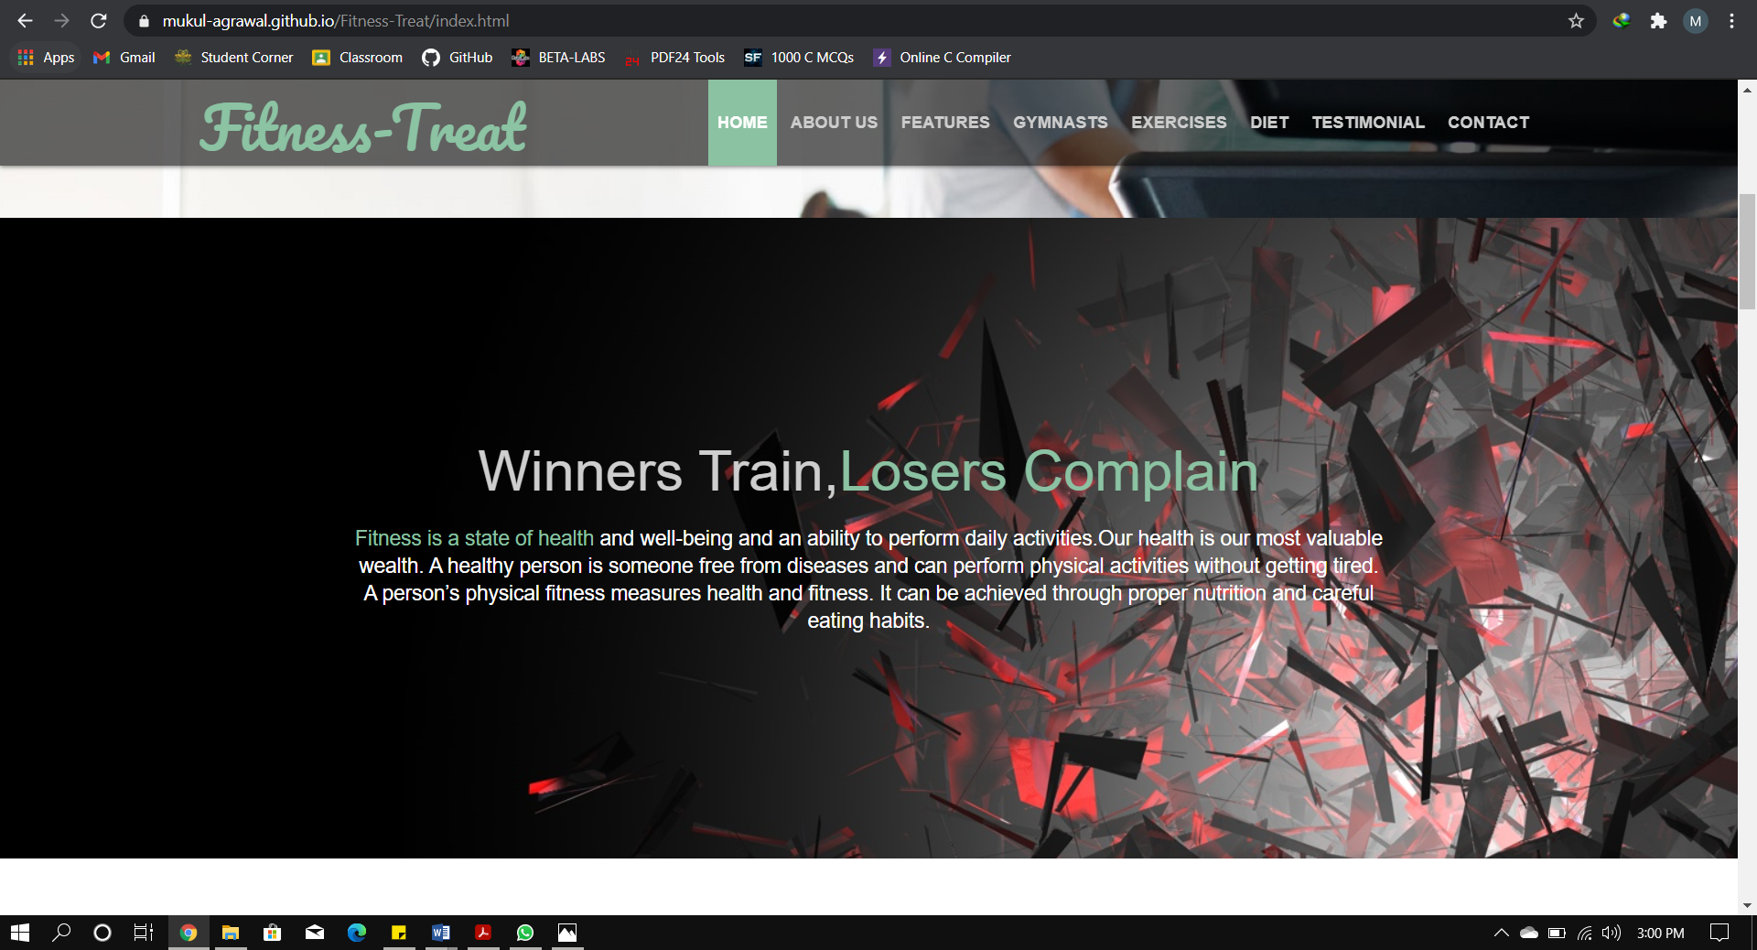

**Fig.4.2: About Us**

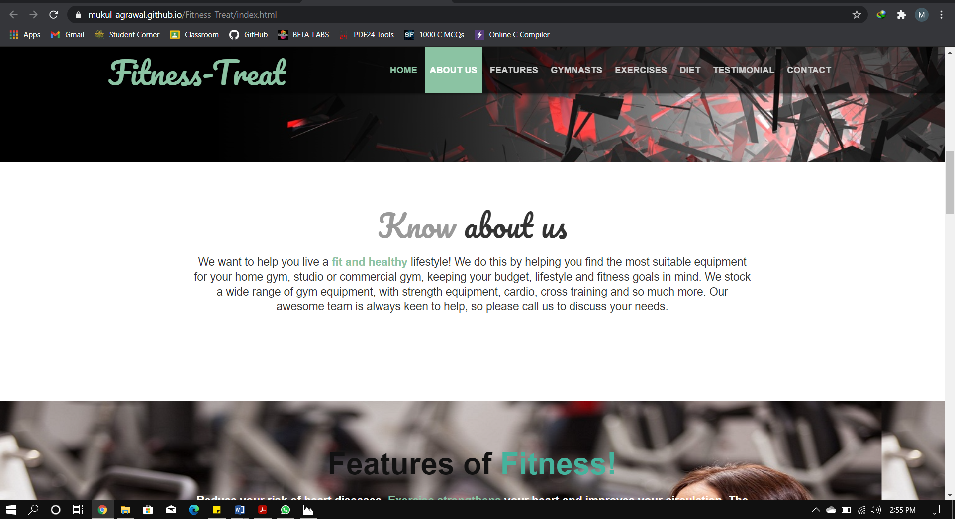**Fig.4.3: Features**

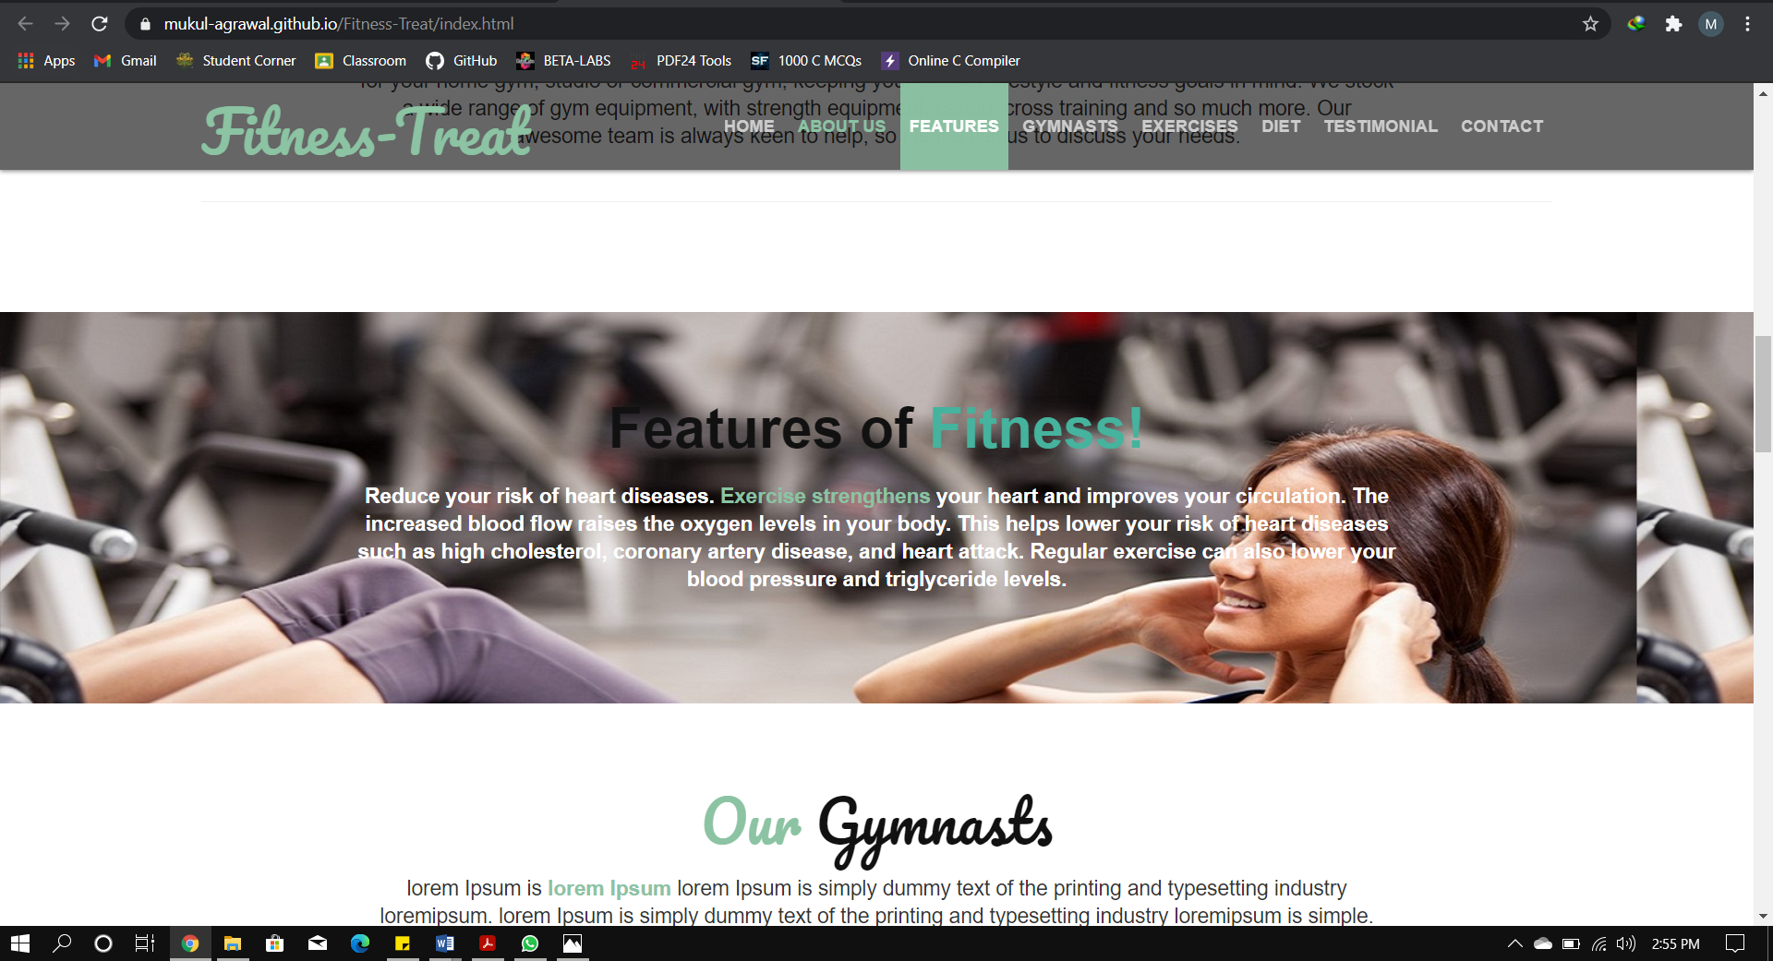

**Fig.4.4: Gymnasts**

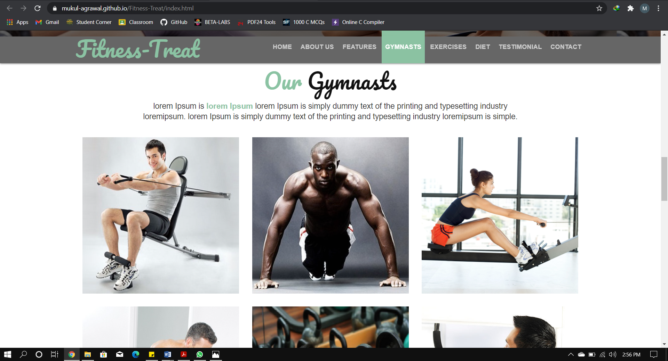**Fig.4.5: Exercises**

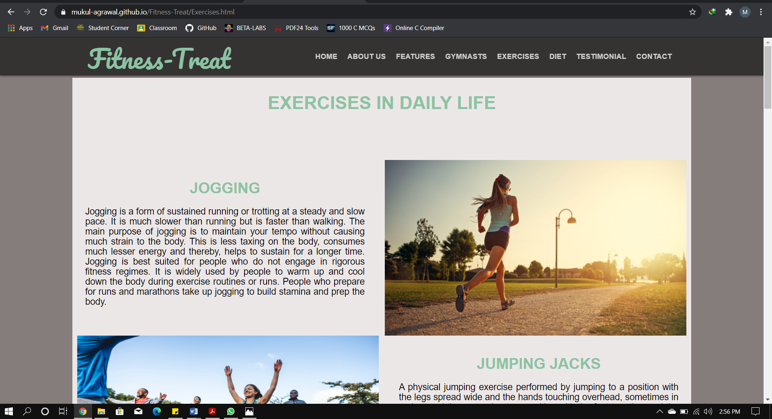

**Fig.4.6: Diet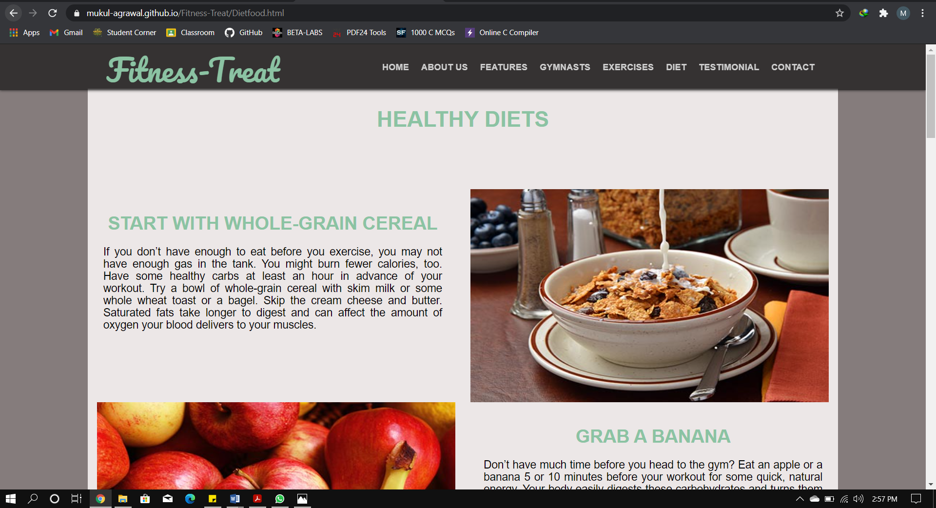Fig.4.7: Testimonial**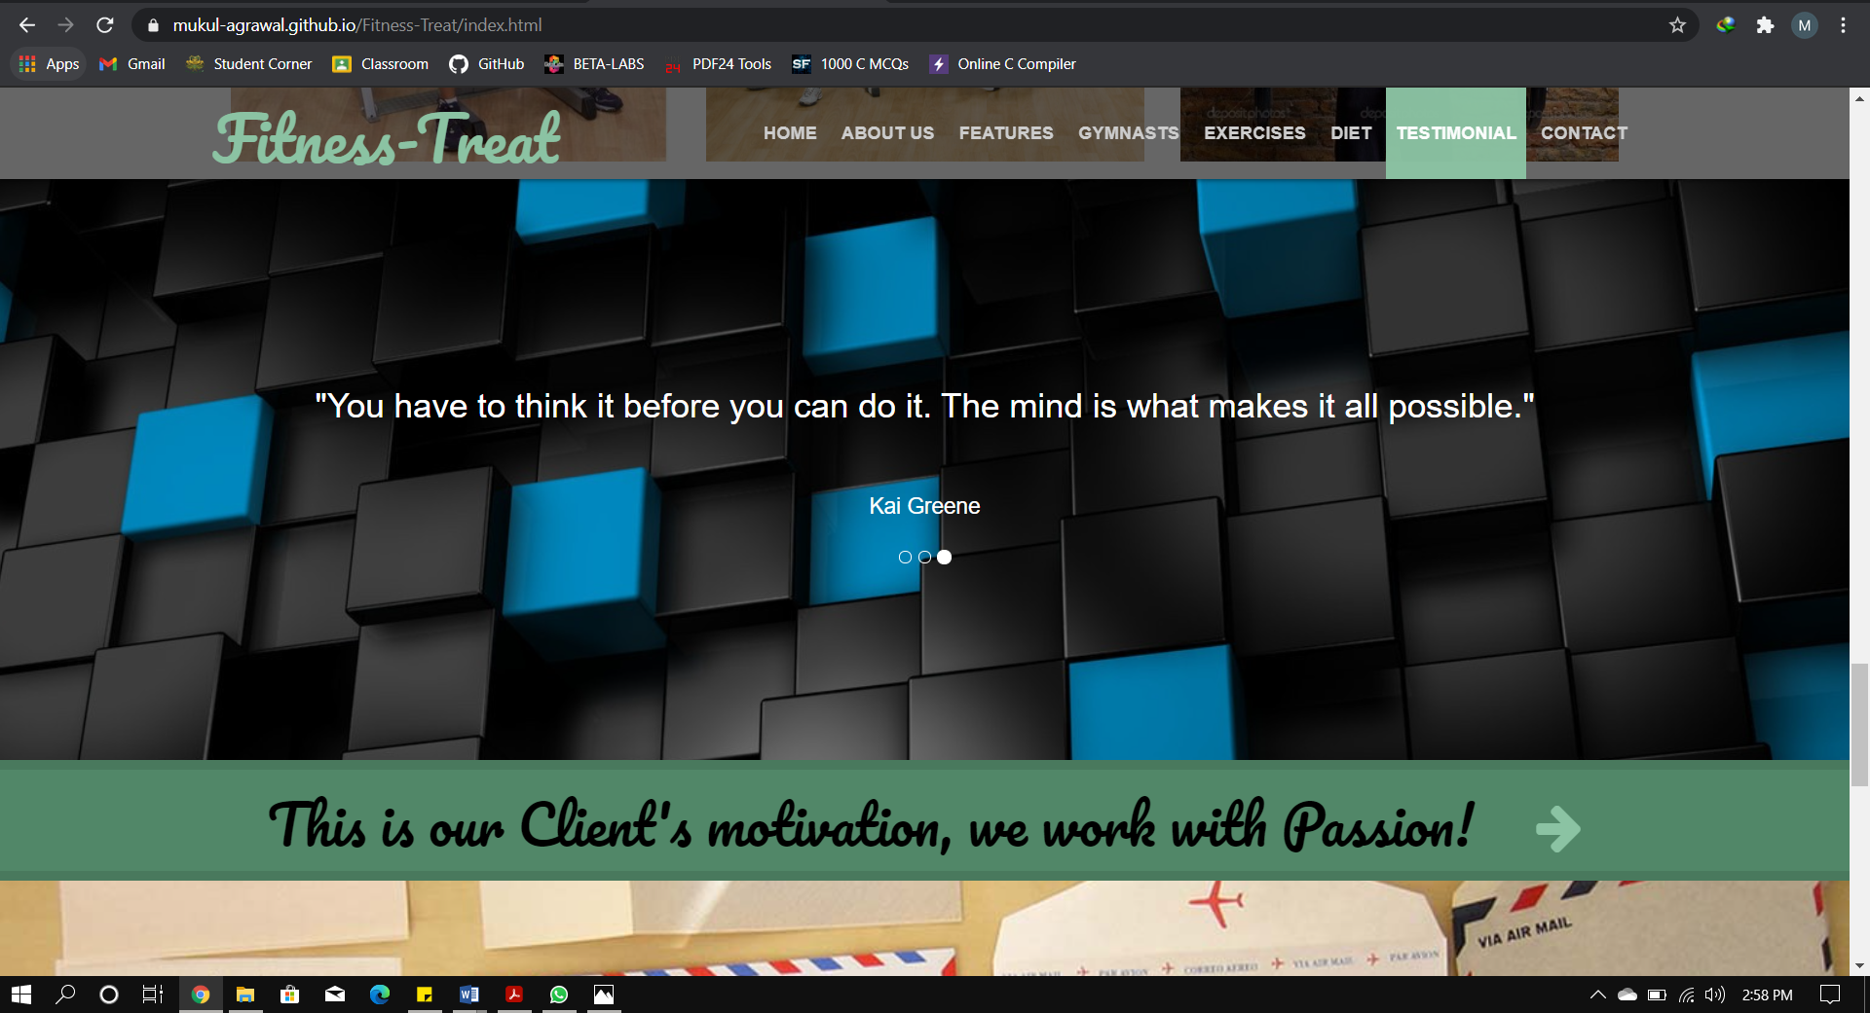

**Fig.4.8: Contact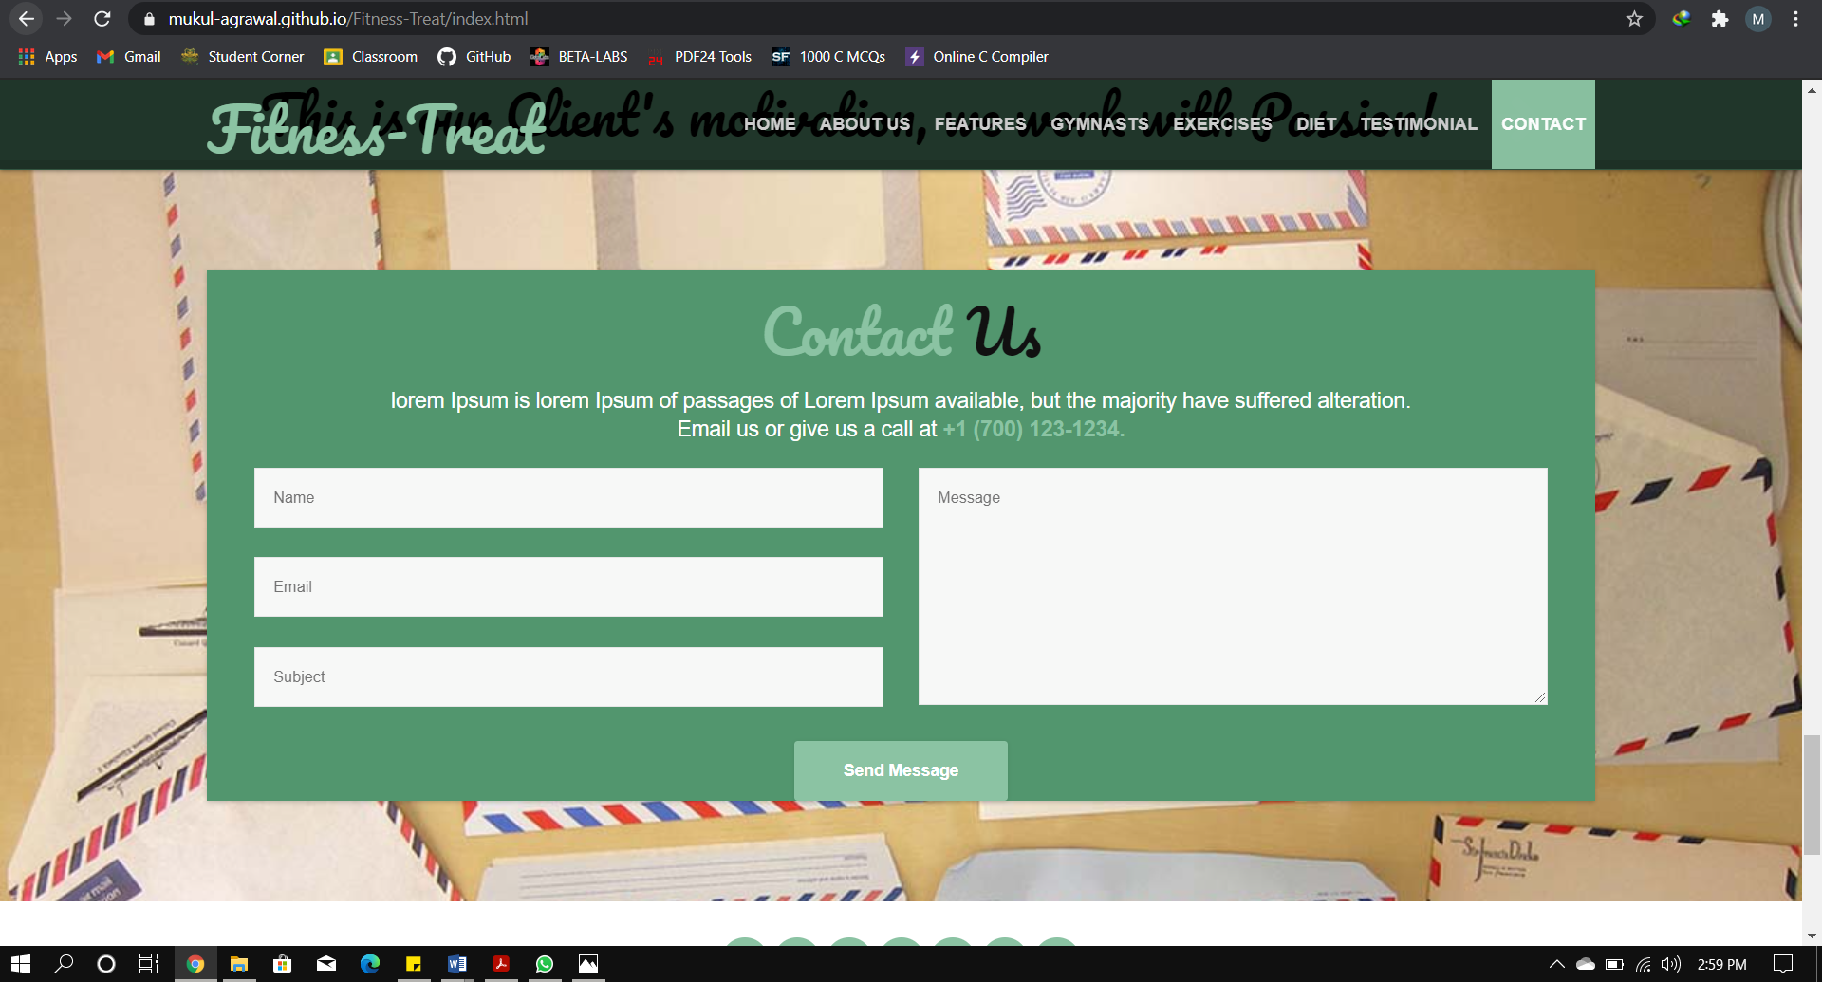Fig.4.9: Footer**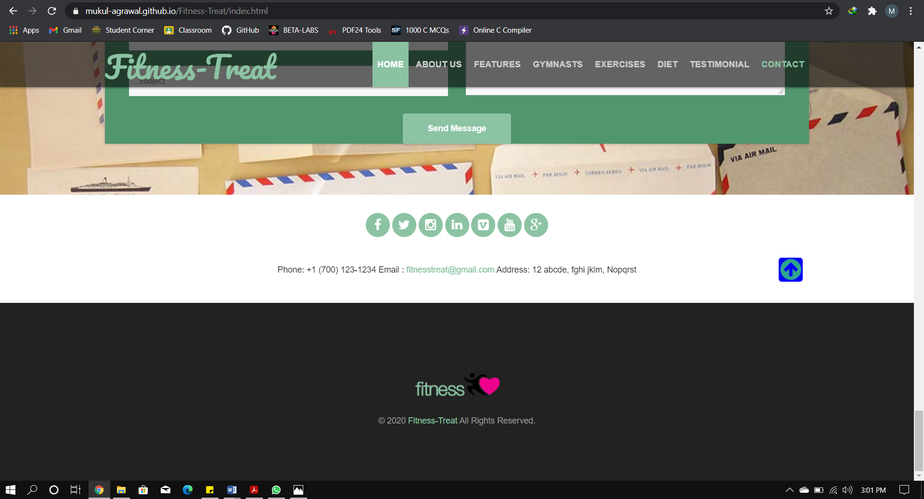

* 1. **SOFTWARE TESTING**

## 5.1Testing

* Software testing is the process of executing a program with intension of finding errors in the code. It is a process of evolution of system or its parts by manual or automatic means to verify that it is satisfying specified or requirements or not.
* Generally, no system is perfect due to communication problems between user and developer, time constraints, or conceptual mistakes by developer.
* To purpose of system testing is to check and find out these errors or faults as early as possible so losses due to it can be saved.
* Testing is the fundamental process of software success.
* Testing is not a distinct phase in system development life cycle but should be applicable throughout all phases i.e. design development and maintenance phase.
* Testing is used to show incorrectness and considered to success when an error is detected.

## Objectives of Software Testing

**Software Quality Improvement:**

The computer and the software are mainly used for complex and critical applications and a bug or fault in software causes severe losses. So a great consideration is required for checking for quality of software.

**Verification and Validation:**

Verification means to test that we are building the product in right way .i.e. are we using the correct procedure for the development of software so that it can meet the user requirements.

Validation means to check whether we are building the right product or not.

**5.3Software Testing**

**Software Reliability Estimation:**

The objective is to discover the residual designing errors before delivery to the customer. The failure data during process are taken down in order to estimate the software reliability.

* + **Principles of Software Testing**
* All tests should be traceable to end user requirements.
* Tests should be planned long before testing begins
* Testing should begin on a small scale and progress towards testing in large
* To be most effective testing should be conducted by an independent third party

The primary objective for test case design is to derive a set of tests that has the highest livelihood for uncovering defects in software. To accomplish this objective two different categories of test case design techniques are used. They are

* **White box testing.**
* **Black box testing.**

**5.3.1 White-box testing:**

White box testing focus on the program control structure. Test cases are derived to ensure that all statements in the program have been executed at least once during testing and that all logical conditions have been executed.

**5.3.2 Block-box testing:**

Black box testing is designed to validate functional requirements without regard to the internal workings of a program. Black box testing mainly focuses on the information domain of the software, deriving test cases by partitioning input and output in a manner that provides through test coverage. Incorrect and missing functions, interface errors, errors in data structures, error in functional logic are the errors falling in this category.

## 5.4 Testing fundamentals

Testing is a process of executing program with the intent of finding error. A good test case is one that has high probability of finding an undiscovered error. If testing is conducted successfully it uncovers the errors in the software. Testing cannot show the absence of defects, it can only show that software defects present.

## 5.5 Testing Information flow

Information flow for testing flows the pattern. Two class of input provided to test the process. The software configuration includes a software requirements specification, a design specification and source code.

Test configuration includes test plan and test cases and test tools. Tests are conducted and all the results are evaluated. That is test results are compared with expected results. When erroneous data are uncovered, an error is implied and debugging commences.

* 1. **CONCLUSION**

This was the first considerably large and important project undertaken by me during my B.Tech course. It was an experience that changed the way I perceived project development. The coding could not be started before the whole system was completely finalized. Even then there were so many changes required and the coding needed to be changed. We attribute this to inadequate information gathering from the user. Though there were many meetings with the user and most of the requirements were gathered, a few misinterpretations of the requirements still crept in. It made me realize how important the systems analysis phase is. The project is a classic example, that learning of concepts needs to be supplemented with application of that knowledge.

On the whole it was a wonderful experience developing **Fitness-Treat** and we would have considered my education incomplete without undertaking such a project which allowed us to apply all that I have learnt and tried to develop a project that can be useful for public. It is developed using html, css, JavaScript, bootstrap so that it can be accessed very easily and at any time. The system will be capable of providing exercises with their description to the users within a given time frame with no errors and the system will be available and operational all the time. The system is developed with an aim of usability so that it is an easy to use system that requires the least amount of user input possible. For using this system general computer knowledge is enough.

**7. BIBLIOGRAPHY & REFERENCES**

To develop this web application of Fitness-treat, we used HTML, CSS, JavaScript and Bootstrap for Front End.

References:

1. https://www.beta-labs.in/
2. https://www.w3schools.com/
3. https://developer.mozilla.org/en-US/